|  |  |
| --- | --- |
| **PLC Splitter** | **Bare Fiber PLC Splitter** |
|  |  |

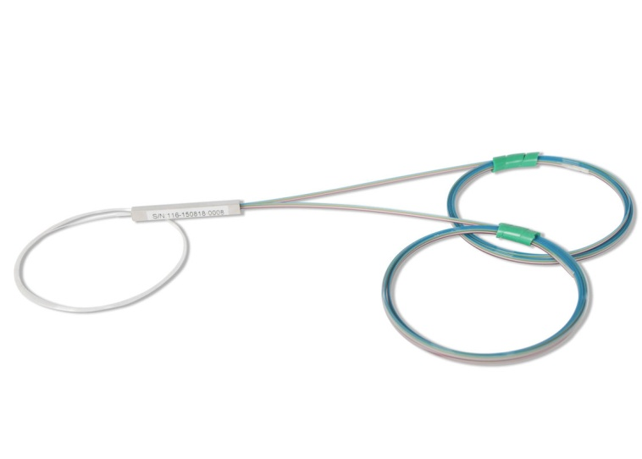 **FEATU**

**DESCRIPTION**

Welltech Enterprises PLC splitter is based on silicon dioxide waveguides, which is used to connect main equipment and terminal equipment in EPON, BPON and GPON network.

**FEATURES**

* Qualified with CE certificate and ROHS certificate.
* Comply with GR-1209-CORE, GR-1221-CORE, YD/T 2000.1-2014 and IEC criterion.

**HOUSING SIZE AND RIBBION:**

**T 3.1 bare fiber PLC splitter housing size and ribbon**

|  |  |  |  |  |  |
| --- | --- | --- | --- | --- | --- |
|  | nx2, nx4, 1x8 | 2x8、nx16 | nx32 | nx64 | ribbon |
|  |  |  |  |  |  |
| L(mm） | 40 | 50 | 60 | 60 | Color: blue, orange, green, brown, grey, |
|  |  |  |  |  |  |
| W(mm） | 4 | 7 | 7 | 12 | white,red, black or customized |
|  |  |  |  |  | Supplier: YOFC, Fiberhome, Corning |
| H(mm） | 4 | 4 | 4 | 4 |
|  |  |  |  |  |  |

**OPTICAL PARAMETER:**

|  |  |  |  |  |  |  |  |  |  |  |  |  |  |
| --- | --- | --- | --- | --- | --- | --- | --- | --- | --- | --- | --- | --- | --- |
|  |  |  | | |  |  |  |  | |  | | | |
|  |  | |  |  | **T 4.1 1×N (N≥2) bare fiber PLC splitter optical parameter** | | | | | | | | | | | | | | |  |
|  |  | |  |  | Parameter | | | | 1X2 | |  | 1x4 |  | | 1x8 |  | 1x16 |  | 1x32 | 1x64 |
|  |  | |  | |  | | | |  | |  |  |  | |  | |  |  |  |  |
|  |  | | Wavelength (nm) | | | | | |  | |  |  |  | | 1260 ～ 1650 | | | |  |  |
|  |  | |  |  |  | | | |  | |  |  |  | |  |  |  |  |  |  |
|  |  | |  |  | IL (dB) | | | | ≤3.8 | |  | ≤7.2 |  | | ≤10.3 |  | ≤13.5 |  | ≤16.8 | ≤20.1 |
|  |  | |  |  |  | | | |  | |  |  |  | |  |  |  |  |  |  |
|  |  | |  | Uniformity (dB) | | | | | ≤0.6 | |  | ≤0.7 |  | | ≤0.8 |  | ≤1.0 |  | ≤1.5 | ≤2.0 |
|  |  | |  |  |  | | | |  | |  |  |  | |  |  |  |  |  |  |
|  |  | |  |  | RL (dB) | | | |  | |  |  |  | |  |  | ≥55 | |  |  |
|  |  | |  |  |  | | | |  | |  |  |  | |  |  |  |  |  |  |
|  |  | |  |  | PDL (dB) | | | | ≤0.15 | |  | ≤0.2 |  | | ≤0.2 |  | ≤0.3 |  | ≤0.3 | ≤0.3 |
|  |  | |  |  |  | | | |  | |  |  |  | |  |  |  |  |  |  |
|  |  | |  | Directivity (dB) | | | | | ≥55 | |  | ≥55 |  | | ≥55 |  | ≥55 |  | ≥55 | ≥55 |
|  |  | |  |  |  | | | |  | |  |  |  | |  |  |  |  |  |  |
|  |  | |  |  | Operating temp(℃) | | | |  | |  |  |  | |  | -40~85℃ | | |  |  |
|  |  | |  |  |  | | | |  | |  |  |  | |  |  |  |  |  |  |
|  | Environ | | |  | Storage temp(℃) | | | |  | |  |  |  | |  | -40~85℃ | | |  |  |
|  |  |  | | | |  | |  |  |  | |  |  |  |  |  |  |
|  |  | Humidity | | | |  | |  |  |  | | ≤95% (+40℃) | | | |  |  |
|  | ment | |  |  |  | |  |  |  | |  |  |
|  |  |  |  | | | |  | |  |  |  | |  |  |  |  |  |  |
|  |  |  | Atmospheric | | | |  | |  |  |  | |  | 62~106kPa | | |  |  |
|  |  | |  |  |  | |  |  |  | |  |  |  |
|  |  | |  |  | pressure | | | |  | |  |  |  | |  |  |  |
|  |  | |  |  |  | |  |  |  | |  |  |  |  |  |  |
|  |  | |  |  |  | | | |  | |  |  |  | |  | |  |  |  |  |
|  |  | |  |  | Fiber | | | |  | |  |  |  | | SM, G657A or customized | | | |  |  |
|  |  | |  |  |  | | | |  | |  | | | |  | |  |  | |  |
|  |  | |  | Ribbon color | | | | | Blue, orange, green, brown, grey, white, red, black or customized | | | | | | | | | | | |
|  |  | | | |  | | | |  | |  |  |  | |  | |  |  | |  |
|  | Output length (mm) | | | | | | | |  | |  |  | 1000, 1500, 2000 or customized | | | | | | |  |
|  |  | |  |  |  | | | |  | |  |  |  | |  |  |  |  |  |  |

**T4.2 2×N (N≥2)bare fiber PLC splitter optical parameter**

|  |  |  |  |  |  |  |  |  |  |  |  |
| --- | --- | --- | --- | --- | --- | --- | --- | --- | --- | --- | --- |
|  |  | Parameter | 2X2 | 2x4 |  | 2x8 |  | 2x16 |  | 2x32 | 2x64 |
|  |  |  |  |  |  |  | |  |  |  |  |
|  | Wavelength (nm) | |  |  |  | 1260 ～ 1650 | | | |  |  |
|  |  |  |  |  |  |  |  |  |  |  |  |
|  |  | IL (dB) | ≤4.0 | ≤7.5 |  | ≤10.6 |  | ≤13.9 |  | ≤17.1 | ≤20.5 |
|  |  |  |  |  |  |  |  |  |  |  |  |
|  | Uniformity (dB) | | ≤0.8 | ≤1.0 |  | ≤1.0 |  | ≤1.5 |  | ≤1.8 | ≤2.0 |
|  |  |  |  |  |  |  |  |  |  |  |  |
|  |  | RL (dB) |  |  |  |  |  | ≥55 | |  |  |
|  |  |  |  |  |  |  |  |  |  |  |  |
|  |  | PDL (dB) | ≤0.2 | ≤0.2 |  | ≤0.3 |  | ≤0.3 |  | ≤0.3 | ≤0.4 |
|  |  |  |  |  |  |  |  |  |  |  |  |
|  | Directivity (dB) | | ≥55 | ≥55 |  | ≥55 |  | ≥55 |  | ≥55 | ≥55 |
|  |  |  |  |  |  |  |  |  |  |  |  |
|  |  | Operating temp(℃) |  |  |  |  | -40~85℃ | | |  |  |
|  |  |  |  |  |  |  |  |  |  |  |  |
| Environ | | Storage temp(℃) |  |  |  |  | -40~85℃ | | |  |  |
|  |  |  |  |  |  |  |  |  |  |
| Humidity |  |  |  | ≤95% (+40℃) | | | |  |  |
| ment |  |  |  |  |  |  |
|  |  |  |  |  |  |  |  |  |  |  |
|  | Atmospheric |  |  |  |  | 62~106kPa | | |  |  |
|  |  |  |  |  |  |  |  |
|  |  | pressure |  |  |  |  |  |  |
|  |  |  |  |  |  |  |  |  |  |  |
|  |  |  |  |  |  |  | |  |  |  |  |
|  |  | Fiber |  |  |  | SM, G657A or customized | | | |  |  |
|  |  |  |  |  | |  | |  |  | |  |
|  |  | Ribbon | Blue, orange, green, brown, grey, white, red, black or customized | | | | | | | | |
|  | |  |  |  |  |  | |  |  | |  |
| Ribbon length（mm） | | |  |  | 1000, 1500, 2000 or customized | | | | | |  |
|  |  |  |  |  |  |  |  |  |  |  |  |